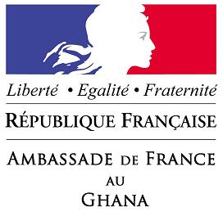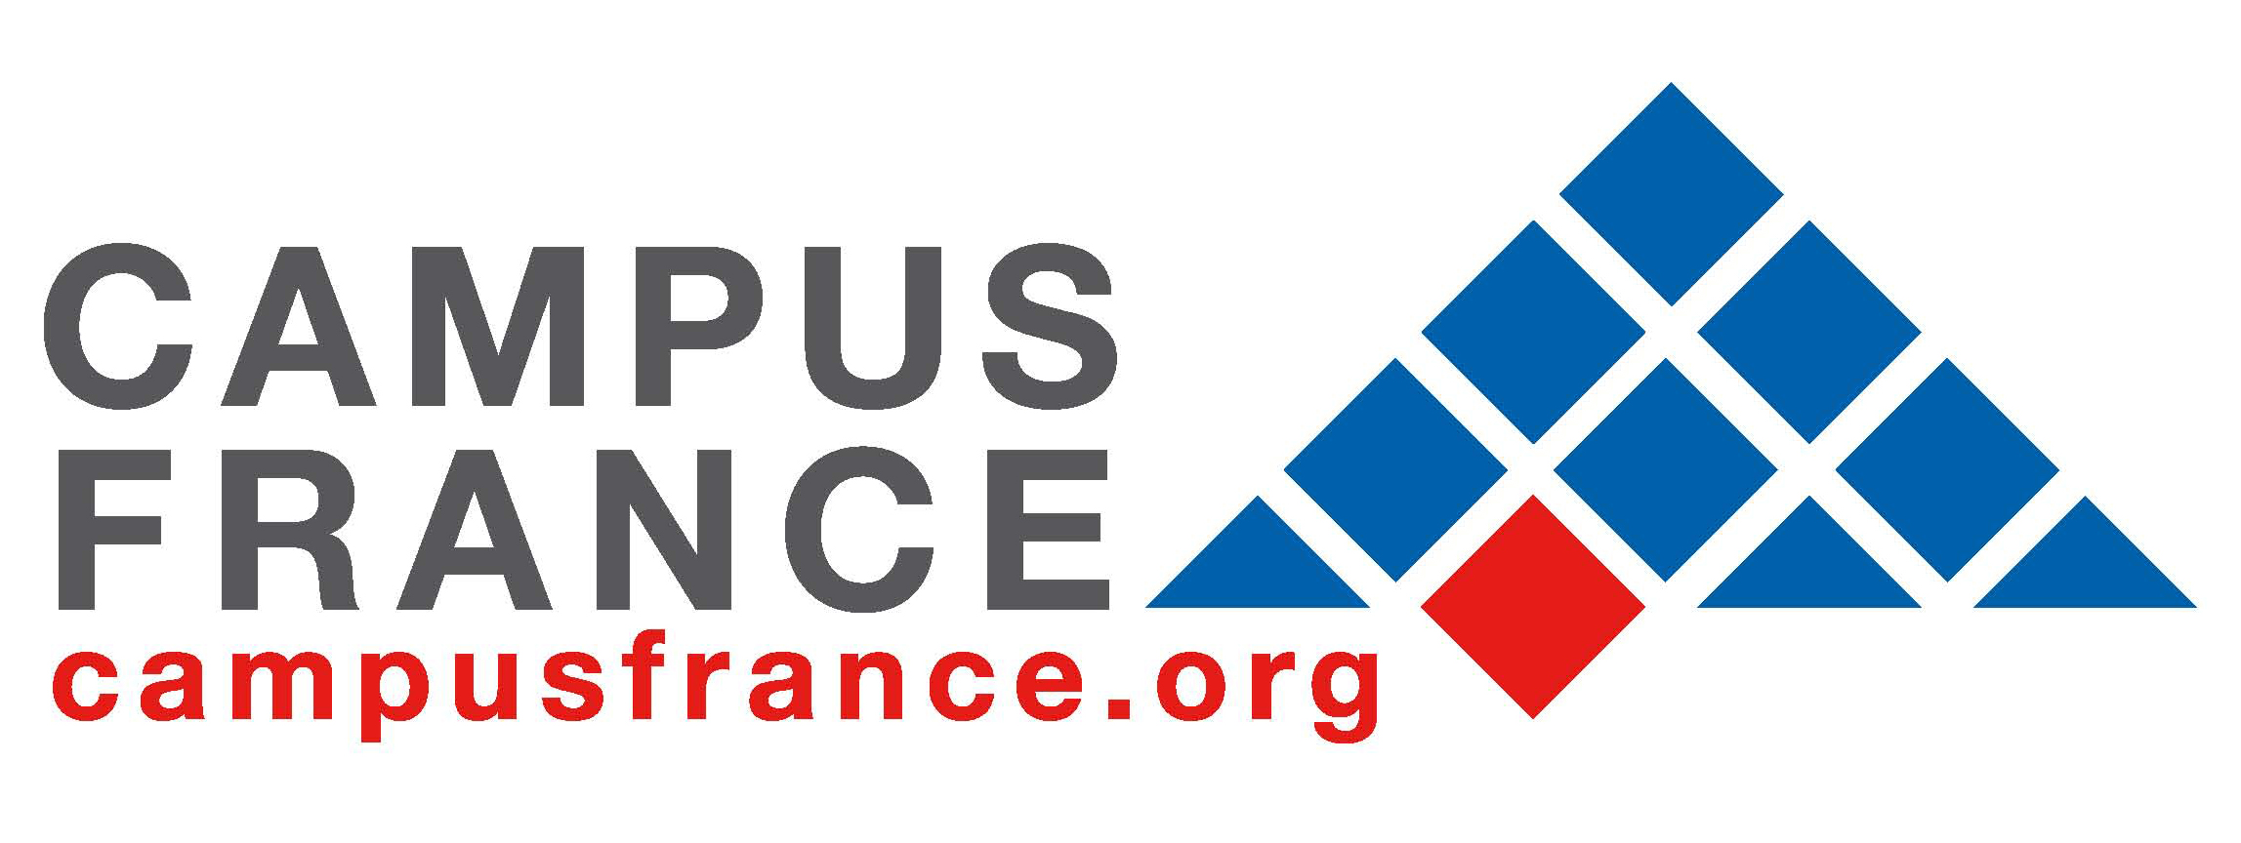

MASTER DEGREE & PhD SCHOLARSHIP PROGRAMMES 2016-2017
FOR GHANAIAN STUDENTS

EMBASSY OF FRANCE IN GHANA

Within the framework of academic cooperation between France and Ghana, the French Embassy in Accra offers some scholarships to Ghanaian students at Master and PhD levels for academic year 2016-2017.

Description and benefits of the scholarship programmes

Two types of scholarship will be offered according to the candidates project:

For Master’s applicants:
Duration and benefits
- 24 months of scholarship including:
  - 2 return tickets to France
  - Free Visa
  - Free university basic registration fees
  - Health insurance
  - Living allowance of 440 Euros/month*

(*Selected candidates will have to provide additional revenues of a minimum of 330 Euros/month – about 1355 GHC/month – either provided by their Ghanaian university, a private source of funding, or personal revenues)

For PhD’s applicants:
Duration and benefits
- 3 stays in France of 6 months each, over a period of three-year including :
  - 3 return tickets to France (1 for each stay)
  - Free Visa
  - Free university basic registration fees
  - Health insurance
  - Living costs will can be covered by the Ghanaian University (for example by providing the full salary for lecturers, or personal resources*)

(*Selected candidates will have to provide proofs of revenues of a minimum of 770 Euros/month – about 3160 GHC/month – either provided by their Ghanaian university, a private source of funding, or personal revenues.)

Conditions of application

Age limit:
35 years for applicants of a Master degree and 40 years for those of PhD.

Academic level
Bachelor Degree for a Master Mphil Degree for a PhD

Fields of studies

Agriculture & food industry
Biology
Chemistry
Environment & earth sciences
Languages & literature
Management, finance and business
Mathematics
Physics
Health sciences
Economics & political science
Humanities & social studies

Mastering of French:

French proficiency is not a compulsory condition for application.

- For Master Degrees, non-francophone students can apply to a wide-range of Programmes taught in English by various French Universities.
- For PhDs, students can do their research and write their thesis in English.

However, mastering of French language is an asset.

Application
How to apply?

Applications must be sent to the Institut Français at the French Embassy in Ghana, 12th avenue off Independence Road, PO BOX 187 ACCRA

An acknowledgement of receipt will be sent to applicants by e-mail.

Please note that applications sent by e-mail are not accepted

Deadline:
Friday 18th, March, 2016 – 12.30 pm

Compulsory documents:

- Application form to be downloaded and completed
- Copies of full academic transcripts and certificates
- Curriculum Vitae
- Copies of birth certificate
- Proof of registration or pre-registration with a French university
- Description of the Research subject – 1 page (for PhDs candidates)
- Cover letter
- Reference letter from your Ghanaian University

DOWLOAD THE APPLICATION FORM Link

Selection:

A committee set up by the French Embassy will pre-select the candidates for an interview before final selection.

The list of selected candidates will be posted on the Embassy website: www.ambafrance-gh.org and also on the website of Espace Campus France Ghana www.ghana.campusfrance.org from May 2, 2016.

Websites:
Embassy of France in Ghana: www.ambafrance-gh.org
Campus France Ghana : www.ghana.campusfrance.org

Information on French Higher Education Programmes
www.campusfrance.org

Contact:
For information on French higher education or on compulsory documents requested, contact Campus France at Maison Française, Legon : Daniel Doe : campusfranceghana@gmail.com or
Campus France at Maison Française de KNUST, Kumasi : Céline Verhaeghe : frenchcoordinator.knust@gmail.com

